**Oracle12c-CentOS 6.5 单机版图形界面安装**

**目 录**

1 环境配置 3

1.1 yum安装配置 3

1.2 安装桌面环境 3

1.3 使用yum安装依赖包 3

1.4 检查安装包 3

1.5 修改内核参数 3

1.6 设置 Shell对Oracle用户的限制 4

1.7 修改selinux 5

1.8 配置hostname 5

2 设置交换区 6

2.1 查看交换分区 6

2.2 增加交换分区 6

3 用户及用户组创建 6

4 解压缩文件 7

5 本地启动Xmanager - Passive 7

6 软件安装 7

7 设置环境变量 15

8 创建数据库 16

9 配置监听和TNS 28

10 配置和优化 29

11 启动Linux大页 30

11.1 参考值计算 30

11.2 修改 /etc/security/limits.conf 32

11.3 编辑 /etc/sysctl.conf 32

11.4 监控 oracle 使用使用hugepage 33

12 设置开启自启动 33

# 环境配置

## yum安装配置

默认是可用的，如不可用，则先解决。

## 安装桌面环境

yum -y groupinstall "X Window System" "Desktop"

## 使用yum安装依赖包

|  |
| --- |
| yum install binutils compat-libstdc++-33 elfutils-libelf libaio libaio-devel sysstat glibc glibc-common glibc-devel glibc-headers ksh make libgcc libstdc++ libstdc++-devel gcc gcc-c++ elfutils-libelf elfutils-libelf-devel elfutils-libelf elfutils-libelf-devel libtool-ltdl ncurses readline unixODBC smartmontools compat-libcap1 |

## 检查安装包

|  |
| --- |
| rpm -q binutils compat-libstdc++-33 elfutils-libelf libaio libaio-devel sysstat glibc glibc-common glibc-devel glibc-headers ksh make libgcc libstdc++ libstdc++-devel gcc gcc-c++ elfutils-libelf elfutils-libelf-devel elfutils-libelf elfutils-libelf-devel libtool-ltdl ncurses readline unixODBC smartmontools compat-libcap1 |

## 修改内核参数

使用文本编辑器将下面列出的行添加到 /etc/sysctl.conf。要使更改立即生效，请执行sysctl -p。（如果参数项存在，则核对数值）kernel.shmmax大小根据实际情况设置 按照规划分配给oracle sga大小计算，如sga=10G，则kernel.shmmax=10*1024*1024*1024=10737418240/4096= 2621440，此处4096 由getconf PAGESIZE 得出。

[root@db1 ~]# tail -n 20 /etc/sysctl.conf

fs.aio-max-nr = 1048576

fs.file-max = 6815744

#配置了最大的内存segment的大小，这个设置要比SGA_MAX_SIZE大

kernel.shmmax = 10737418240

#shmall 是全部允许使用的共享内存大小，shmmax 是单个段允许使用的大小

kernel.shmall = 2621440

kernel.shmmni = 4096

# semaphores: semmsl, semmns, semopm, semmni

kernel.sem = 250 32000 100 128

net.ipv4.ip_local_port_range = 9000 65500

net.core.rmem_default=262144

net.core.rmem_max=4194304

net.core.wmem_default=262144

net.core.wmem_max=1048586

内核参数生效

[root@db1 ~]#sysctl -p

## 设置 Shell对Oracle用户的限制

以root用户身份，在每个节点上执行相同的操作：

首先，修改/etc/security/limits.conf，在文件最后添加如下内容：

oracle soft nproc 2047

oracle hard nproc 16384

oracle soft nofile 1024

oracle hard nofile 65536

oracle soft stack 10240

oracle hard stack 10240

接着，修改/etc/pam.d/login，在文件最后添加如下内容：

session required pam_limits.so

最后，修改/etc/profile，在文件最后添加如下内容：

if [ $USER = "oracle" ]; then

if [ $SHELL = "/bin/ksh" ]; then

ulimit -p 16384

ulimit -n 65536

else

ulimit -u 16384 -n 65536

fi

fi

## 修改selinux

临时关闭：

setenforce 0

永久关闭：

vi /etc/selinux/config

SELINUX=enforcing ====> SELINUX=disabled

**[root@orcl ~]# cat /etc/selinux/config**

|  |
| --- |
| [root@orcl ~]# cat /etc/selinux/config  # This file controls the state of SELinux on the system.  # SELINUX= can take one of these three values:  # enforcing - SELinux security policy is enforced.  # permissive - SELinux prints warnings instead of enforcing.  # disabled - No SELinux policy is loaded.  SELINUX=disabled  # SELINUXTYPE= can take one of these two values:  # targeted - Targeted processes are protected,  # mls - Multi Level Security protection.  SELINUXTYPE=targeted  [root@orcl ~]# |

检查桌面环境是否安装

[root@localhost ~]# export DISPLAY=:0.0

[root@localhost ~]# xhost +

## 配置hostname

编辑/etc/hosts

增加 192.168.130.188 db-ora

修改 /etc/sysconfig/network 中HOSTNAME比如：HOSTNAME=db-ora

192.168.130.188 表示服务器地址

db-ora 表示节点名

# 设置交换区

## 查看交换分区

swapon -s

free -m

cat /proc/swaps

## 增加交换分区

cd /usr/;mkdir swap

#从硬盘里分出一个 32*1G 大小的空间，挂在swapfile上

dd if=/dev/zero of=/usr/swap/swapfile bs=1G count=32

#构建swap格式于/usr/swap/swapfile 上

mkswap /usr/swap/swapfile

#激活swapfile ，加入到swap分区中

swapon /usr/swap/swapfile

#在 /etc/fstab 文件中加入下面一行

/usr/swap/swapfile swap swap defaults 0 0

### 删除交换分区

1、swapoff /usr/swap/swapfile

2、删除/etc/fstab 中 /usr/swap/swapfile 记录

# 用户及用户组创建

groupadd dba

groupadd oinstall

groupadd oper

useradd -g oinstall -G dba,oinstall,oper oracle

passwd oracle 修改密码

# 解压缩文件

unzip linuxamd64_12102_database_1of2.zip

unzip linuxamd64_12102_database_2of2.zip

chown -R oracle:oinstall database

# 本地启动Xmanager - Passive

su - oracle

export DISPLAY=172.16.0.114:0.0

xhost +

172.16.0.114 表示windows机器IP

# 软件安装

[oracle@localhost database]$ ./runInstaller

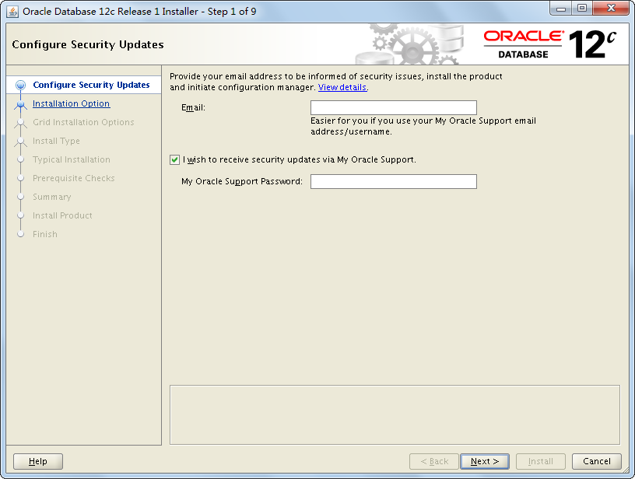

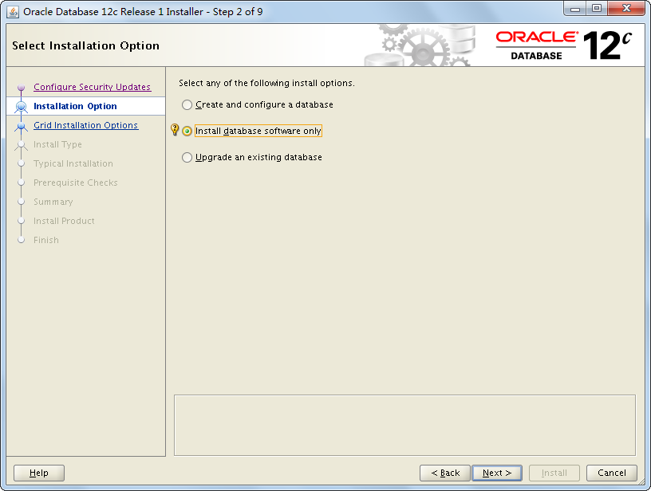

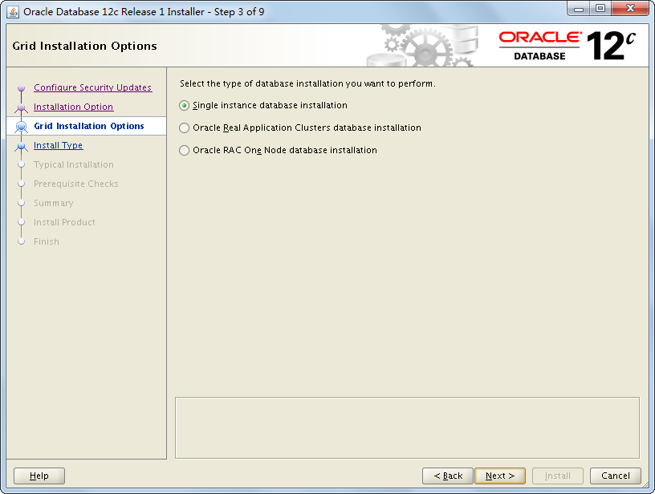

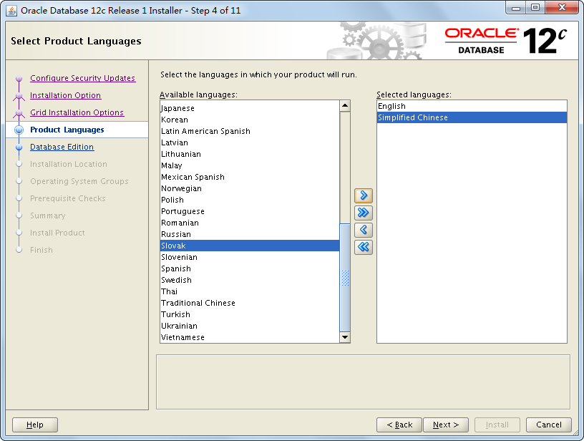

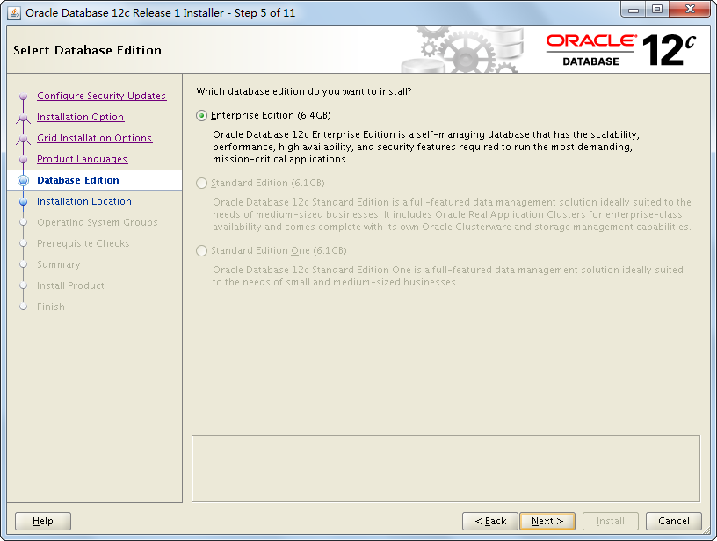

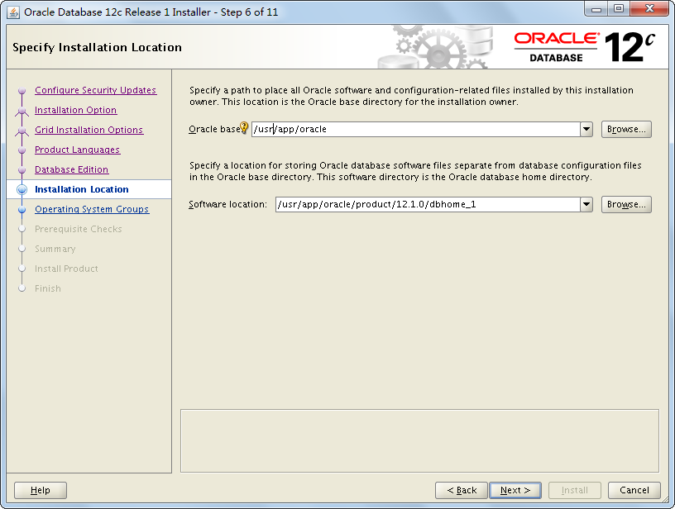

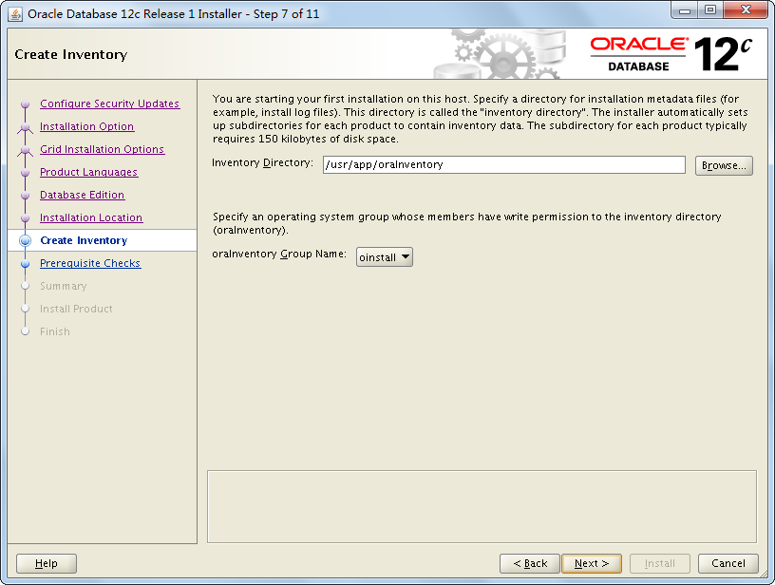

oracle用户必须对/usr/app/oracle 和/usr/app/oraInventory 有读写权限。可以用root用户先创建好，并赋予oracle权限。chown -R oracle:oinstall /usr/app/oracle /usr/app/oraInventory。

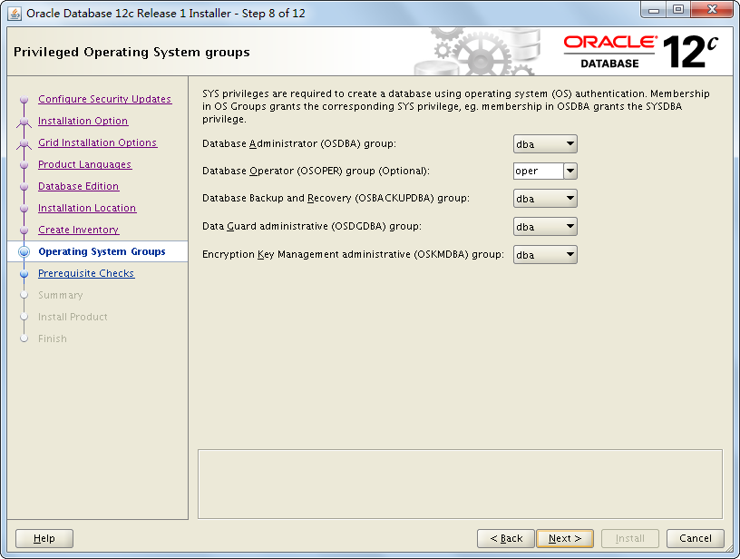

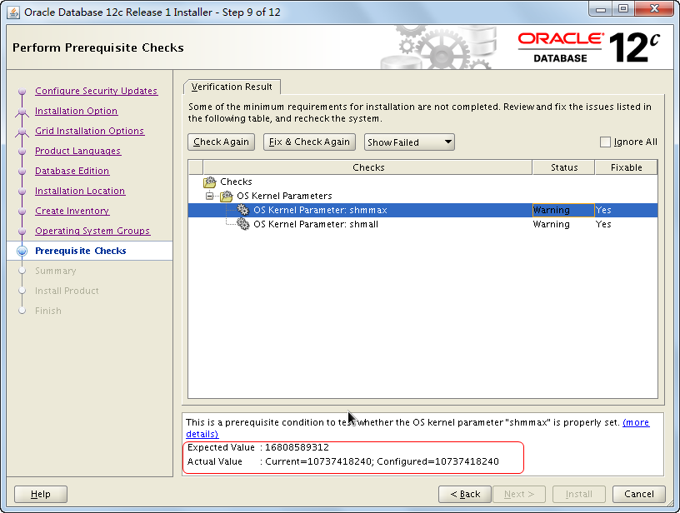

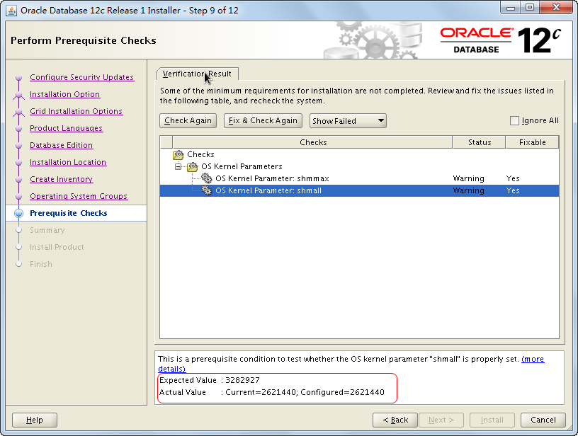

此处警告无需理会，因为本机oracle是以12G参考来设置的，而实际内存32G。

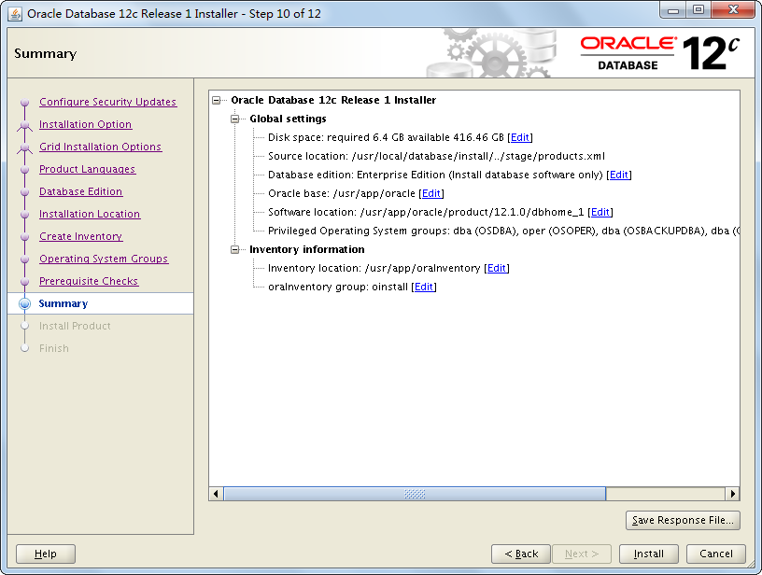

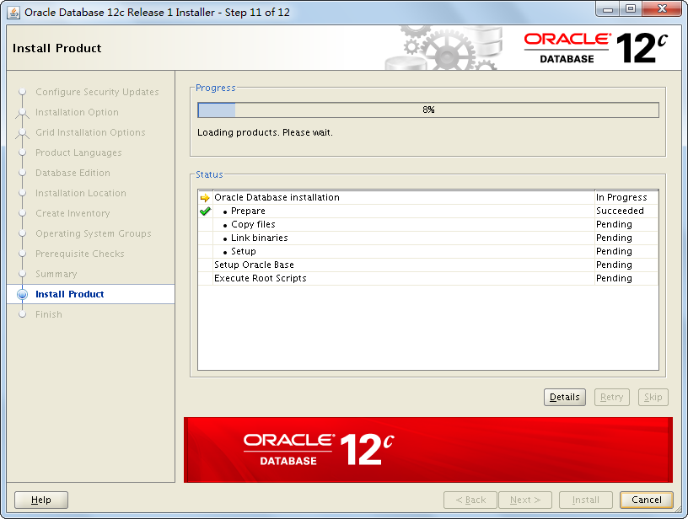

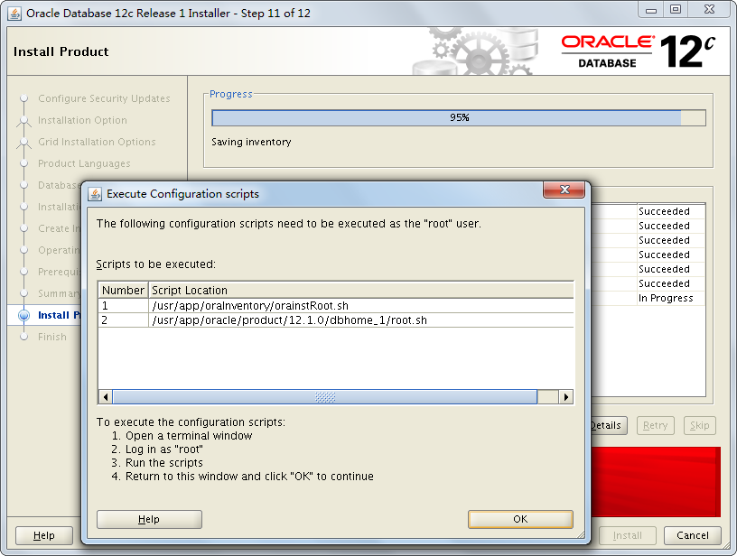

[root@localhost ~]# sh /usr/app/oraInventory/orainstRoot.sh

[root@localhost ~]# sh /usr/app/oracle/product/12.1.0/dbhome_1/root.sh 直接回车

确定 关闭

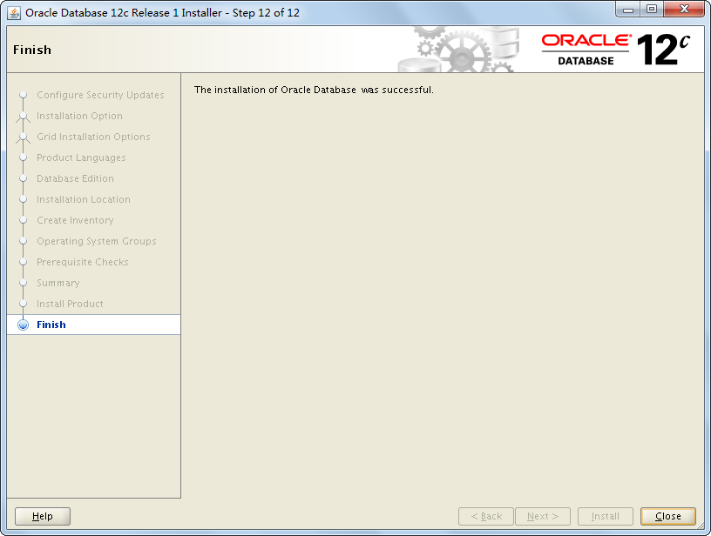

# 设置环境变量

oracle用户执行：

vi ~/.bash_profile

|  |
| --- |
| export LANG=C  export ORACLE_BASE=/usr/app/oracle  export ORACLE_HOME=*$ORACLE_BASE/product/12.1.0/dbhome_1*  export ORACLE_SID=orcl  export PATH=$ORACLE_HOME/bin:$HOME/bin:$PATH:/usr/bin:/bin:/usr/bin/X11:/usr/local/bin  export LD_LIBRARY_PATH=$ORACLE_HOME/lib:$ORACLE_HOME/oracm/lib:/lib:/usr/lib:/usr/local/lib  export TEMP=/tmp  export TMPDIR=/tmp  #NLS_LANG根据应用要求进行设置，通常情况下与数据库字符集一致  export NLS_LANG="*AMERICAN_AMERICA.ZHS16GBK*"  umask 022  echo "oracle 12.1.0 env is set" |

生效

[oracle@localhost database]$ . ~/.bash_profile

# 创建数据库

oracle用户执行：

dbca

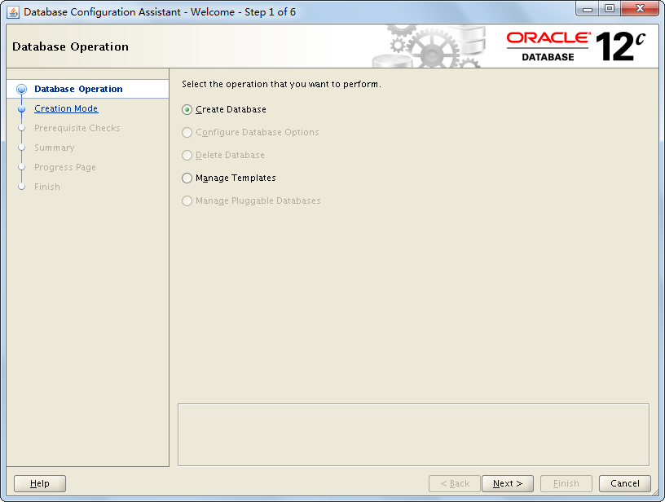

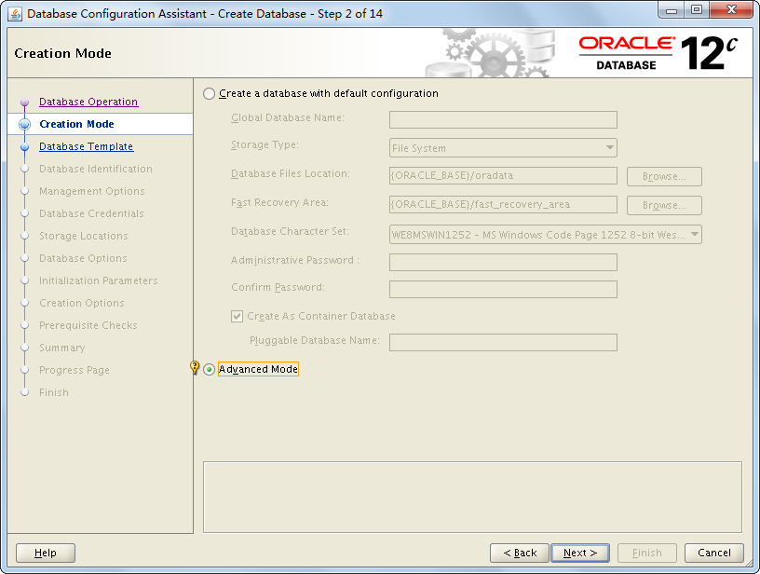

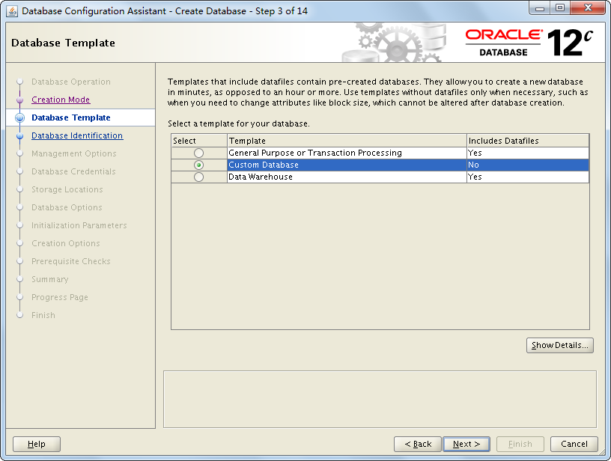

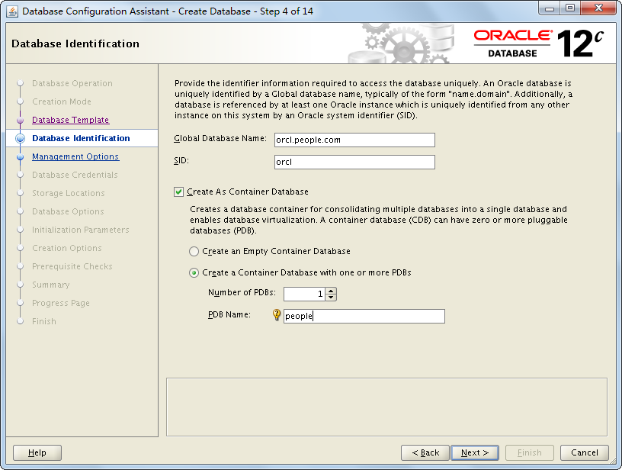

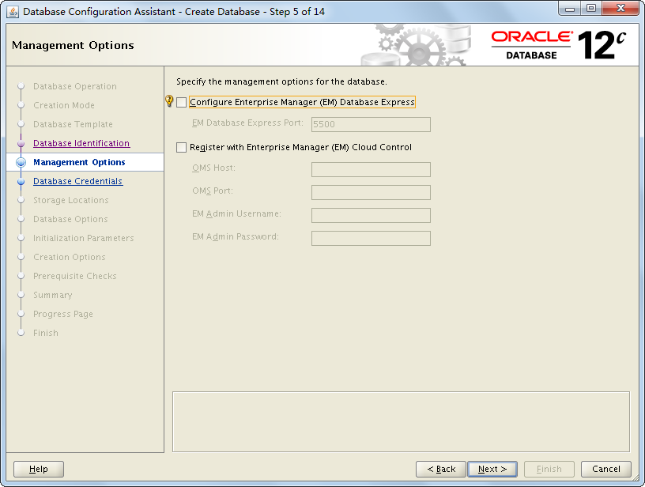

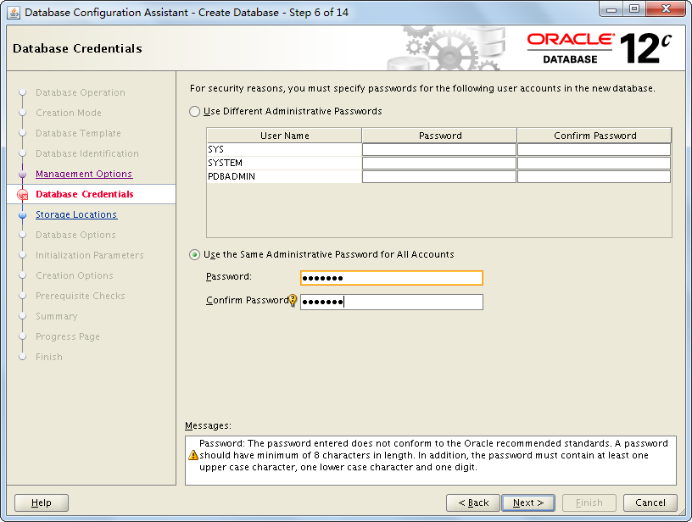

统一密码 sotp123

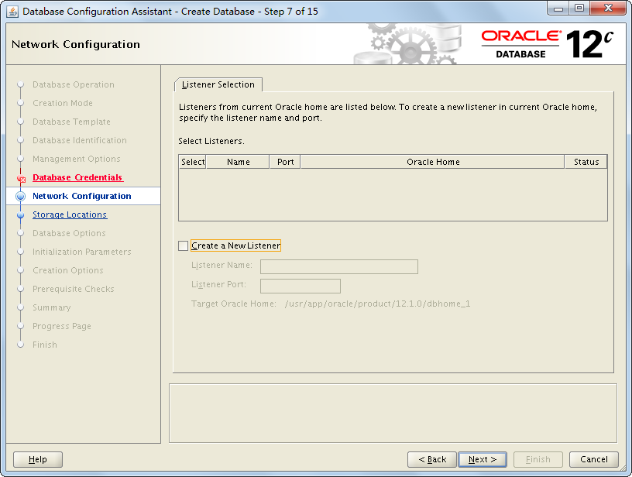

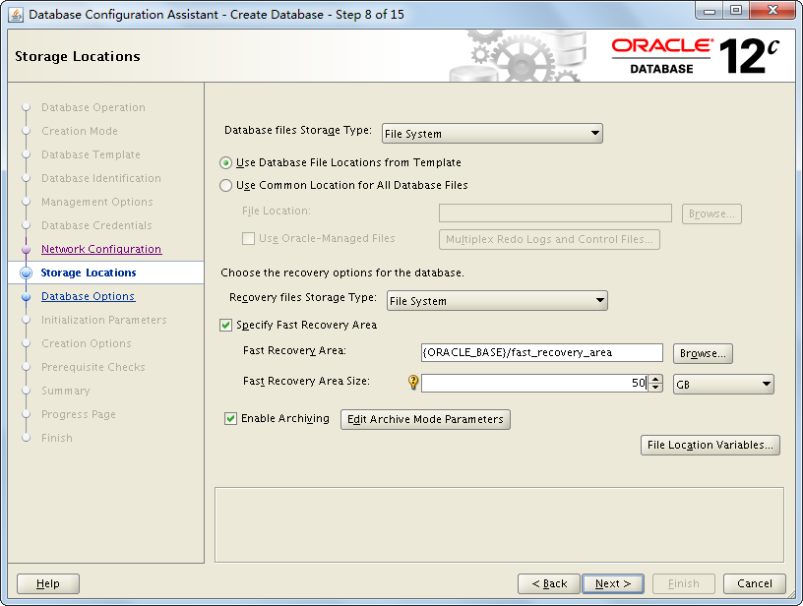

建议开启归档模式，如果只做性能测试用，可考虑关闭，以提高Oracle性能。

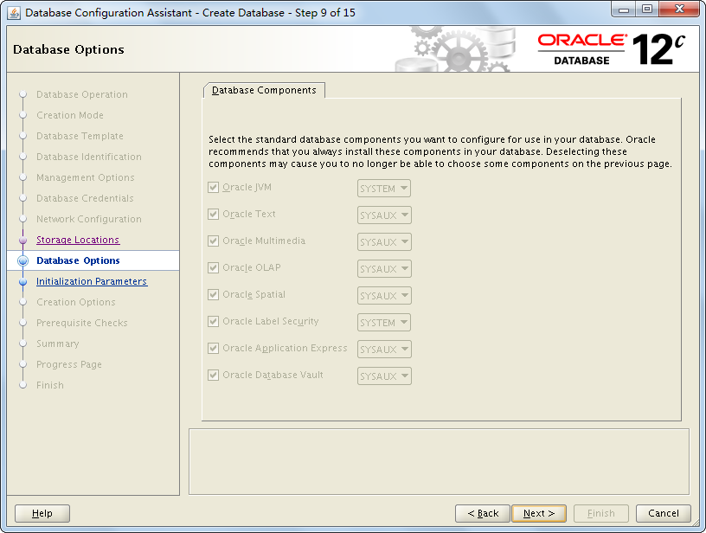

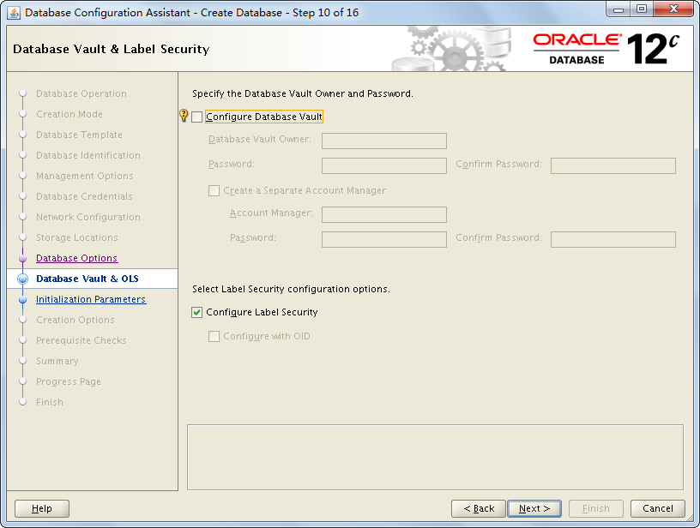

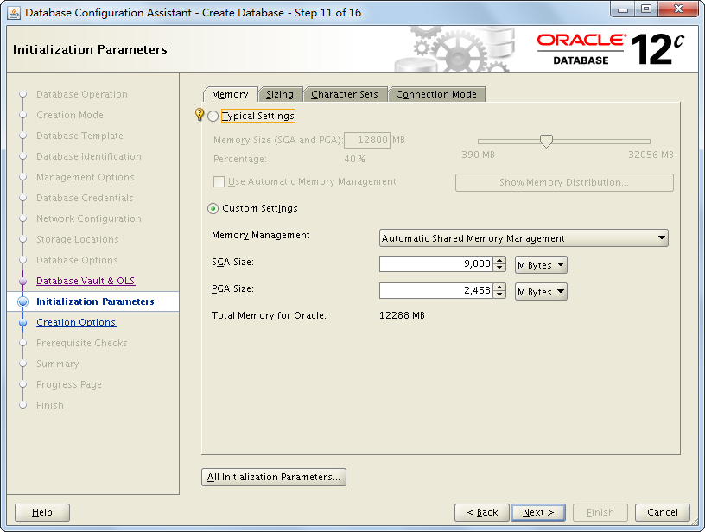

sga=12G*0.8

pga=12G*0.2

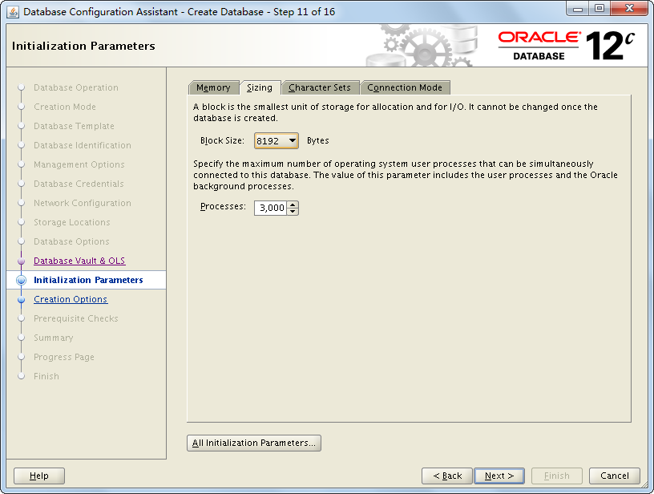

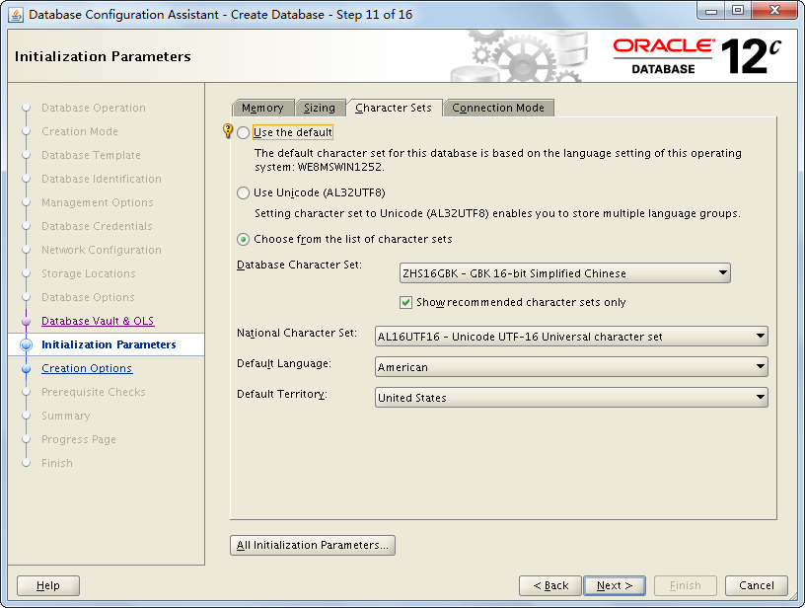

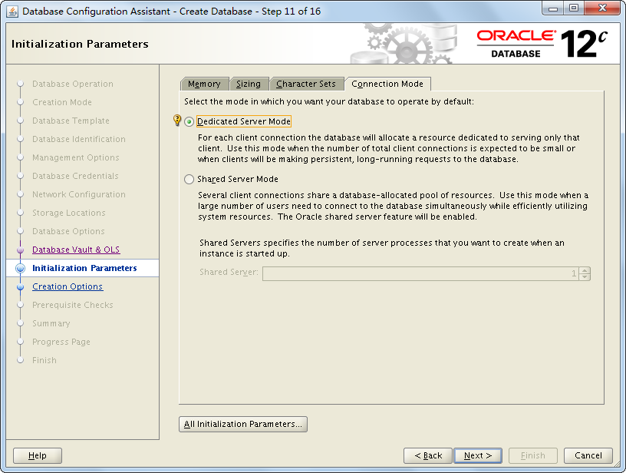

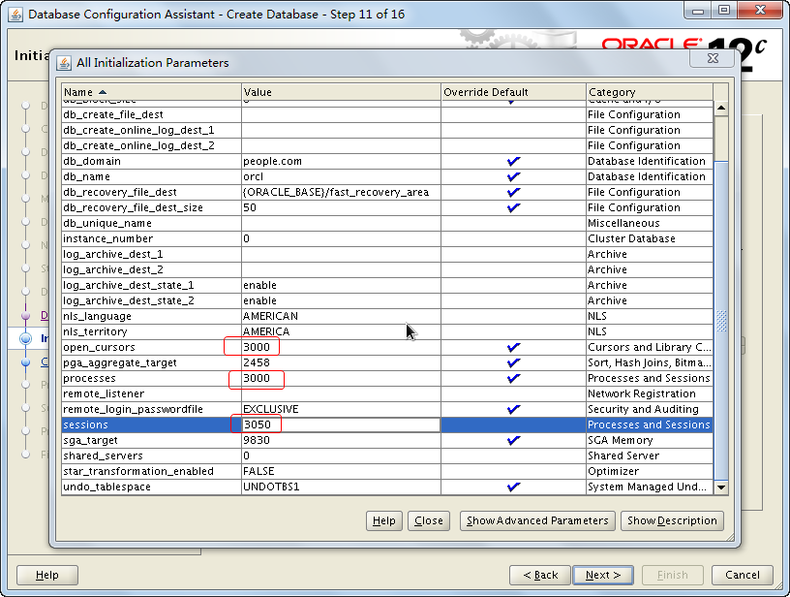

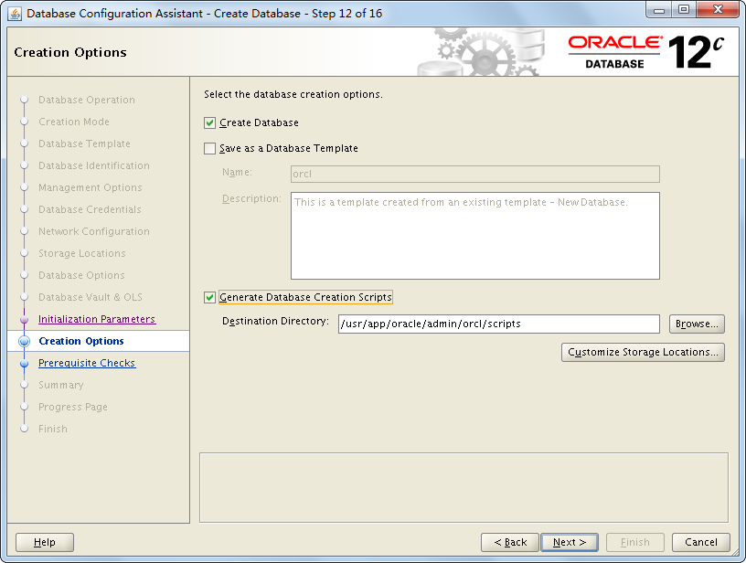

编辑redo 大小和undo大小

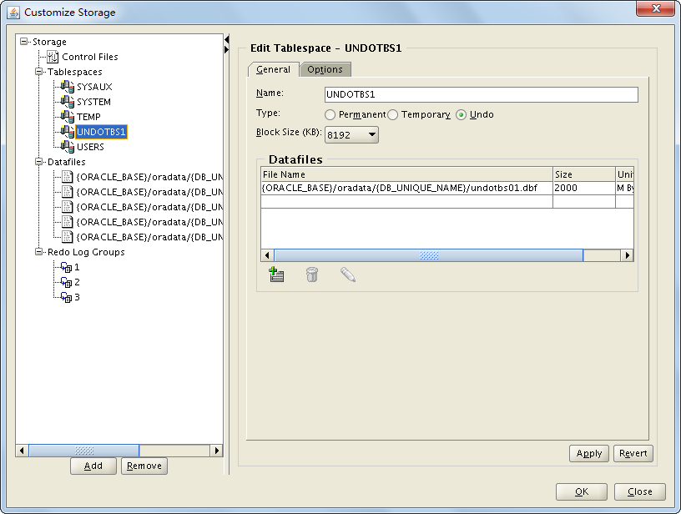

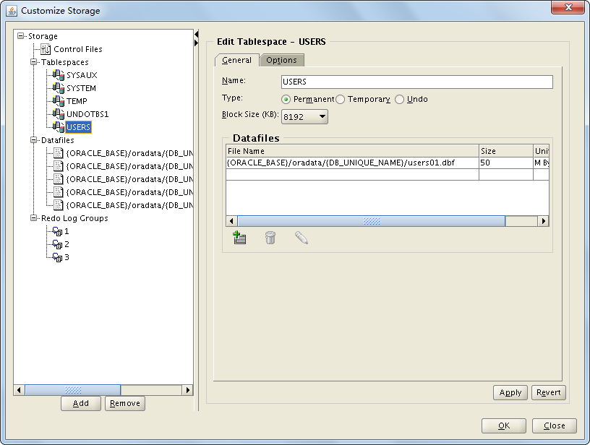

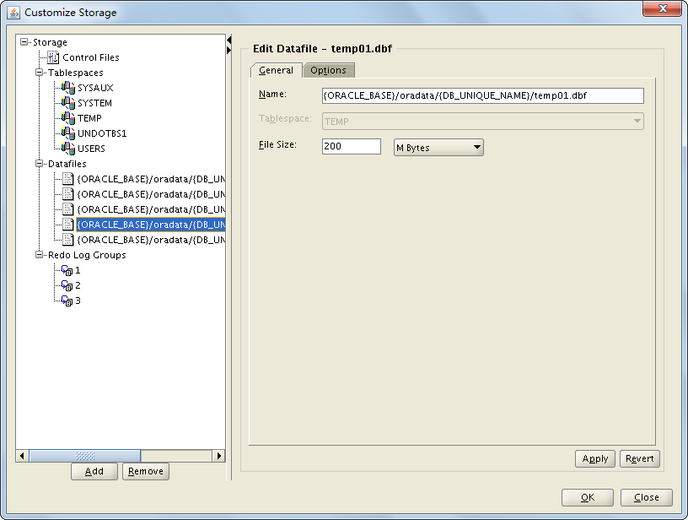

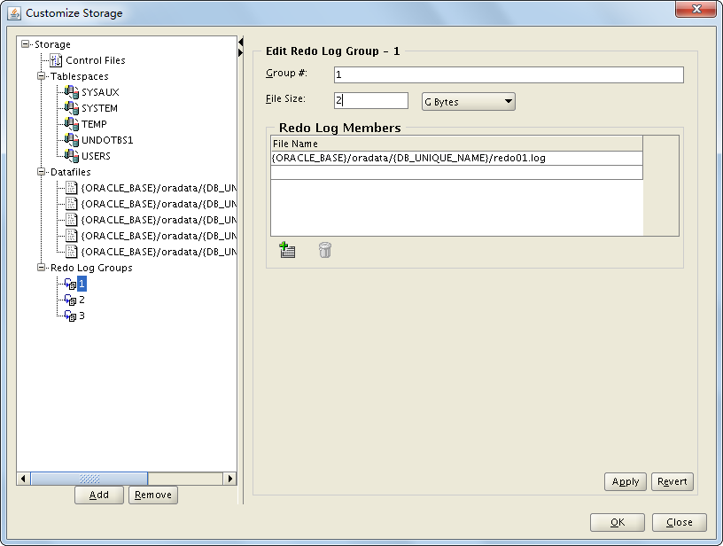

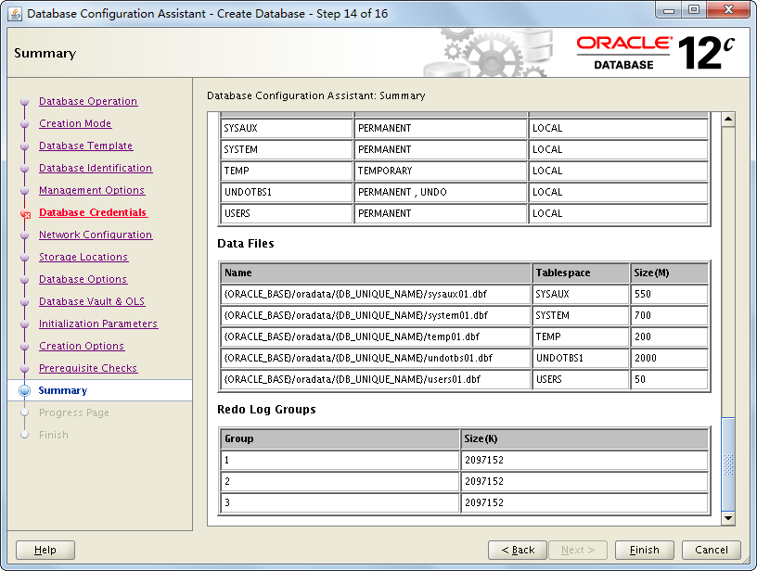

检查各项设置是否是预期规划，否则退回重设。

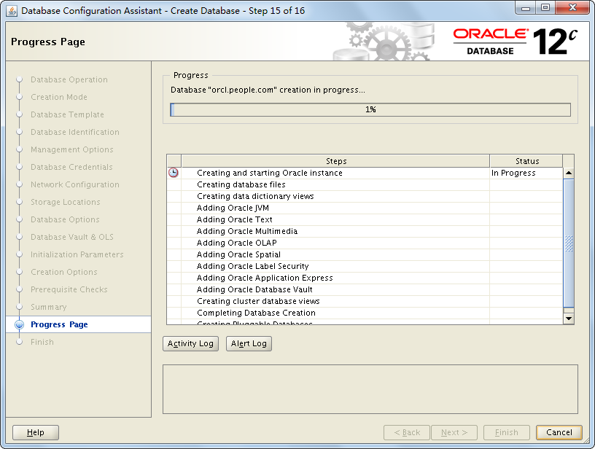

此过程需要1~3小时。

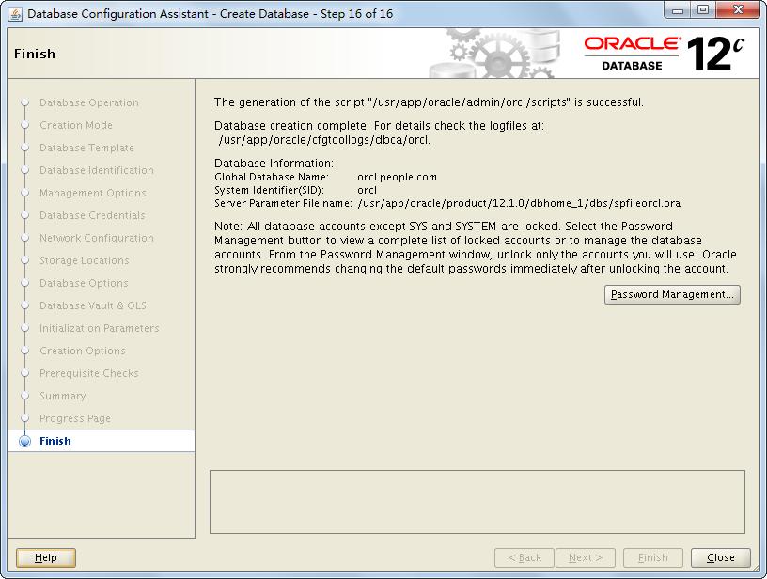

点击close

# 配置监听和TNS

cd $ORACLE_HOME/network/admin

创建文件 listener.ora 内容如下

|  |
| --- |
| # listener.ora Network Configuration File: /usr/app/oracle/product/12.1.0/dbhome_1/network/admin/listener.ora  # Generated by Oracle configuration tools.  LISTENER =  (DESCRIPTION_LIST =  (DESCRIPTION =  (ADDRESS = (PROTOCOL = TCP)(HOST = orcl.people.com)(PORT = 1521))  (ADDRESS = (PROTOCOL = IPC)(KEY = EXTPROC1521))  )  )  SID_LIST_LISTENER =  (SID_LIST =  (SID_DESC =  (GLOBAL_DBNAME = orcl.people.com)  (ORACLE_HOME = /usr/app/oracle/product/12.1.0/dbhome_1)  (SID_NAME = orcl)  )  )  ADR_BASE_LISTENER = /usr/app/oracle |

创建文件tnsnames.ora 内容如下

|  |
| --- |
| ORCL =  (DESCRIPTION =  (ADDRESS_LIST =  (ADDRESS = (PROTOCOL = TCP)(HOST = orcl.people.com)(PORT = 1521))  )  (CONNECT_DATA =  (SERVICE_NAME = orcl.people.com)  )  ) |

启动监听 lsnrctl start

(停 lsnrctl stop 查看状态 lsnrctl status)

测试监听 $ tnsping orcl

# 配置和优化

alter system set max_dump_file_size='1024M';

sqlplus / as sysdba登陆操作 awrrpt 参数修改

select * from dba_hist_wr_control;

select dbid,baseline_name,baseline_type,moving_window_size from dba_hist_baseline;

exec dbms_workload_repository.modify_baseline_window_size(2); -- 修改其大小 为2 ，即两天。

exec DBMS_WORKLOAD_REPOSITORY.MODIFY_SNAPSHOT_SETTINGS(interval=>30,retention => 32*24*60 );

备份spfile参数文件

create pfile='/usr/app/oracle/product/12.1.0.2.0/dbs/spfileorcl1.ora' from spfile;

create pfile='/usr/app/oracle/product/12.1.0.2.0/dbs/spfileorcl2.ora' from spfile;

create spfile='+RACDATA/orcl/spfileorcl.ora' from pfile;

create spfile from pfile;

关闭审计功能

alter system set audit_trail='NONE' scope=spfile;

或在初始化参数中设置：*.audit_trail='NONE'

truncate table SYS.AUD$;

关闭日志跟踪

初始化参数： *.trace_enabled=false

或者 alter system set audit_trail='NONE' scope=spfile;

# 启动Linux大页

在Linux中配置hugepage可以提高oracle的性能，减少oracle sga的页交换，类似于aix中的lagepage。

## 参考值计算

nr_hugepages>=sga(mb)/Hugepagesize(mb)=20972m/2m=10486

使用 hugepages_settings.sh 计算参考值，在参考值的基础上+200

hugepages_settings.sh # oracle 启动状态oracle用户执行

|  |
| --- |
| #!/bin/bash  #  # hugepages_settings.sh  #  # Linux bash script to compute values for the  # recommended HugePages/HugeTLB configuration  #  # Note: This script does calculation for all shared memory  # segments available when the script is run, no matter it  # is an Oracle RDBMS shared memory segment or not.  #  # This script is provided by Doc ID 401749.1 from My Oracle Support  # http://support.oracle.com    # Welcome text  echo "  This script is provided by Doc ID 401749.1 from My Oracle Support  (http://support.oracle.com) where it is intended to compute values for  the recommended HugePages/HugeTLB configuration for the current shared  memory segments. Before proceeding with the execution please note following:  * For ASM instance, it needs to configure ASMM instead of AMM.  * The 'pga_aggregate_target' is outside the SGA and  you should accommodate this while calculating SGA size.  * In case you changes the DB SGA size,  as the new SGA will not fit in the previous HugePages configuration,  it had better disable the whole HugePages,  start the DB with new SGA size and run the script again.  And make sure that:  * Oracle Database instance(s) are up and running  * Oracle Database 11g Automatic Memory Management (AMM) is not setup  (See Doc ID 749851.1)  * The shared memory segments can be listed by command:  # ipcs -m      Press Enter to proceed..."    read    # Check for the kernel version  KERN=`uname -r | awk -F. '{ printf("%d.%d\n",$1,$2); }'`    # Find out the HugePage size  HPG_SZ=`grep Hugepagesize /proc/meminfo | awk '{print $2}'`  if [ -z "$HPG_SZ" ];then  echo "The hugepages may not be supported in the system where the script is being executed."  exit 1  fi    # Initialize the counter  NUM_PG=0    # Cumulative number of pages required to handle the running shared memory segments  for SEG_BYTES in `ipcs -m | cut -c44-300 | awk '{print $1}' | grep "[0-9][0-9]*"`  do  MIN_PG=`echo "$SEG_BYTES/($HPG_SZ*1024)" | bc -q`  if [ $MIN_PG -gt 0 ]; then  NUM_PG=`echo "$NUM_PG+$MIN_PG+1" | bc -q`  fi  done    RES_BYTES=`echo "$NUM_PG * $HPG_SZ * 1024" | bc -q`    # An SGA less than 100MB does not make sense  # Bail out if that is the case  if [ $RES_BYTES -lt 100000000 ]; then  echo "***********"  echo "** ERROR **"  echo "***********"  echo "Sorry! There are not enough total of shared memory segments allocated for  HugePages configuration. HugePages can only be used for shared memory segments  that you can list by command:    # ipcs -m    of a size that can match an Oracle Database SGA. Please make sure that:  * Oracle Database instance is up and running  * Oracle Database 11g Automatic Memory Management (AMM) is not configured"  exit 1  fi    # Finish with results  case $KERN in '2.2') echo "Kernel version $KERN is not supported. Exiting." ;;  '2.4') HUGETLB_POOL=`echo "$NUM_PG*$HPG_SZ/1024" | bc -q`;  echo "Recommended setting: vm.hugetlb_pool = $HUGETLB_POOL" ;;  '2.6') echo "Recommended setting: vm.nr_hugepages = $NUM_PG" ;;  esac    # End |

## 修改 /etc/security/limits.conf

修改或增加（# unit kb 32g=33554432k；-1不限制）

# oracle soft memlock -1

# oracle hard memlock -1

oracle soft memlock 33554432

oracle hard memlock 33554432

## 编辑 /etc/sysctl.conf

增加 vm.nr_hugepages = 10698

sysctl -p 比较慢，可考虑重启服务器

## 监控 oracle 使用使用hugepage

oracle 重启前

[root@rac2 ~]# cat /proc/meminfo | grep -i hugepage

AnonHugePages: 86016 kB

HugePages_Total: 10698

HugePages_Free: 10698

HugePages_Rsvd: 0

HugePages_Surp: 0

Hugepagesize: 2048 kB

oracle 启动后

[root@rac2 ~]# cat /proc/meminfo | grep -i hugepage

AnonHugePages: 86016 kB

HugePages_Total: 10698

HugePages_Free: 201

HugePages_Rsvd: 0

HugePages_Surp: 0

Hugepagesize: 2048 kB

[root@rac2 ~]#

可见hugepage 已经在使用

同过如下命令统计ora内存使用量：

ps -elf | grep ora | awk 'BEGIN{sum=0}{sum=sum+$10}END{print sum/1024/1024/1024 "G"}'

# 设置开启自启动

1、编辑/etc/oratab，将N修改为Y，如下所示：

#orcl:/usr/app/oracle/product/12.1.0/dbhome_1:N

orcl:/usr/app/oracle/product/12.1.0/dbhome_1:Y

2、编辑/etc/rc.d/rc.local 增加如下代码

su oracle -lc /usr/app/oracle/product/12.1.0/dbhome_1/bin/dbstart

su oracle -lc "/usr/app/oracle/product/12.1.0/dbhome_1/bin/lsnrctl start"